**Multimedia Assignment 2**

*Dong Xiaoran 3036032774*

*Ding Jiayi 3036032906*

*Huang Binqian 3036032724*

My work (Huang Binqian): Programming the current information and writing the implementation details and data storing approach.

|  |
| --- |
| Current smart city visualization interface:  http://43.198.19.124:1880/ui/ |

Index

Background 1

Our Work 2

1. Current Information 2

2.Temperature Chart 2

3. Humidity Chart 3

4. UV index Chart 3

5. Rainfall Report 4

6. PM2.5 Report 4

7. Temperature Forecast 5

8. Relative Humidity Forecast 5

Correlation 6

Implementation Details 6

3. Implementation for PM2.5 Chart 10

4. Implementation of Current Information 11

Data Storing Approach 12

**Background**

Smart city originated in the field of media, and refers to the application of intelligent computing technologies such as the Internet of Things, cloud computing, big data, and spatial geographic information integration in the fields of urban planning, design, construction, management, and operation. The key infrastructure components and services that make up the city, such as health care, real estate, transportation, public utilities, and public safety, are more interconnected, efficient, and intelligent, so as to provide better life and work services for citizens and create more favorable business development for enterprises environment, empowering the government with a more efficient operation and management mechanism.

Weather forecasting services must rely on accurate data to be carried out. Therefore, how to forecast the atmospheric environment of the city and its surroundings quickly and accurately is an urgent problem of meteorological data monitoring to meet the real-time application requirements of weather forecast services. We can use smart city meteorological sensors to strengthen the monitoring of various meteorological elements in the environment, such as temperature, humidity, wind speed, wind direction, atmospheric pressure, rainfall, etc., to provide real-time and accurate meteorological data for the operation of smart cities, and to realize the coordination of smart cities run.

In addition, we have added functions such as air quality monitoring, which can detect changes in environmental elements such as PM2.5. Since the urban meteorological and pollutant diffusion monitoring and forecasting model is a numerical model, which is compatible with and optimizes the monitoring and forecasting of urban meteorological and pollutant diffusion data, it is only by mastering the conventional and special meteorological data in the urban area and combining with the numerical model that is the key to the application requirements of urban atmospheric environment emergency response and the production and development of weather forecast services.

**Our Work**

**1. Current Information**

Two dials show the current air temperature and humidity.The text below shows future weather conditions.

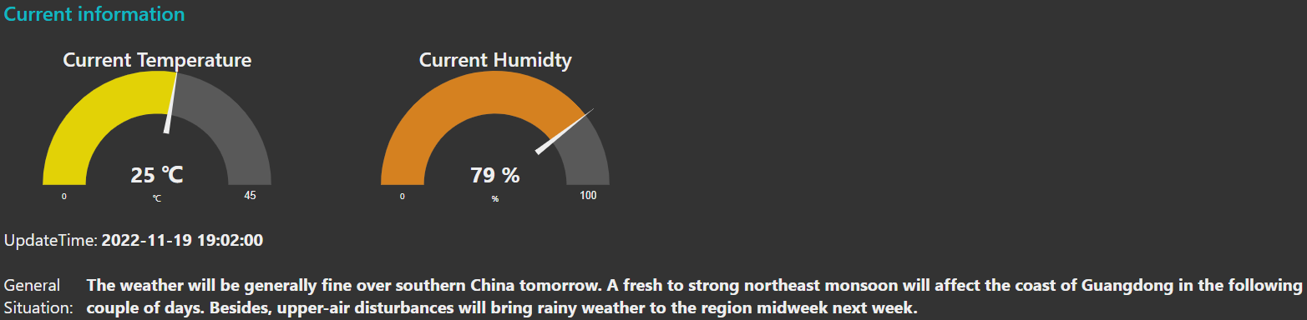

**2.Temperature Chart**

The chart dynamically shows the temperature conditions in various regions of Hong Kong within 18 hours, and the data is recorded every hour. Recently: The temperature is on a downward trend around 17:00, and the temperature in various regions is stable from 18:00 to 7:00. Tai Kwu Ling reaches the lowest temperature in Hong Kong between 4:00 and 7:00. Around 7 o'clock, the temperature in various regions showed an upward trend.

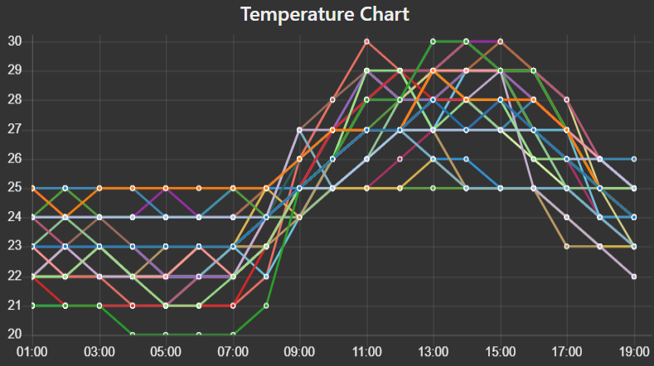

**3. Humidity Chart**

The chart dynamically shows the humidity in Hong Kong over 18 hours, and the data is recorded every hour. Recently: The change of humidity is not very regular, but the peaks appear around 6:00 pm, 9:00 pm, 4-5 am, and 8 am. Humidity drops at noon.

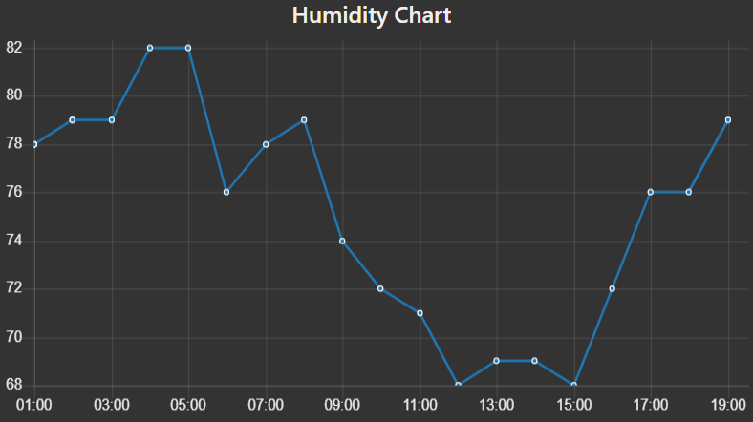

**4. UV index Chart**

The graph dynamically shows the UV conditions in Hong Kong within 24 hours, and the data is recorded every hour. The ultraviolet rays showed an upward trend from 8:00 am, peaked at around 1:00 pm, and then showed a downward trend, and the ultraviolet coefficient was close to 0 at 6:00 pm.

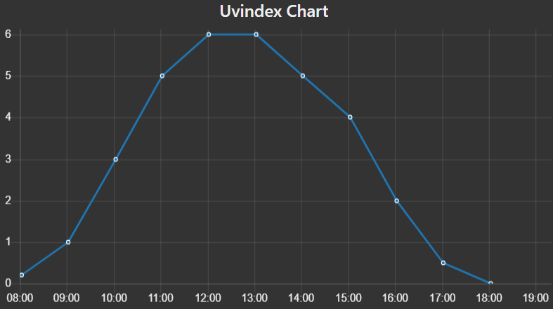

**5. Rainfall Report**

The chart dynamically shows the rainfall in the Hong Kong area in 18 hours, and the data is recorded every hour. There has been no recent rainfall, so the rainfall is 0.

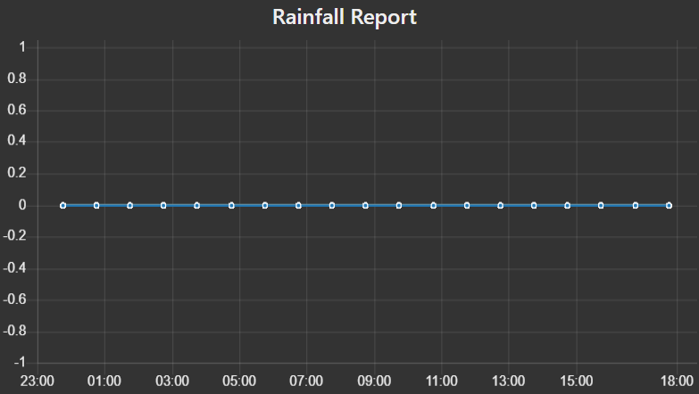

**6. PM2.5 Report**

The graph dynamically shows the PM2.5 situation in Hong Kong within 105 minutes, and the data is recorded every 5 minutes. Peaks occur around 9:00 am and around 11:50 am.

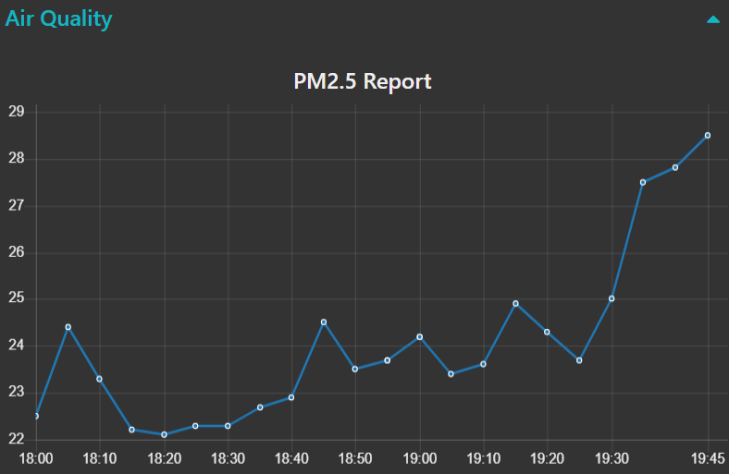

**7. Temperature Forecast**

The chart predicts the temperature in Hong Kong for the next nine days. Temperatures will drop over the next few days.

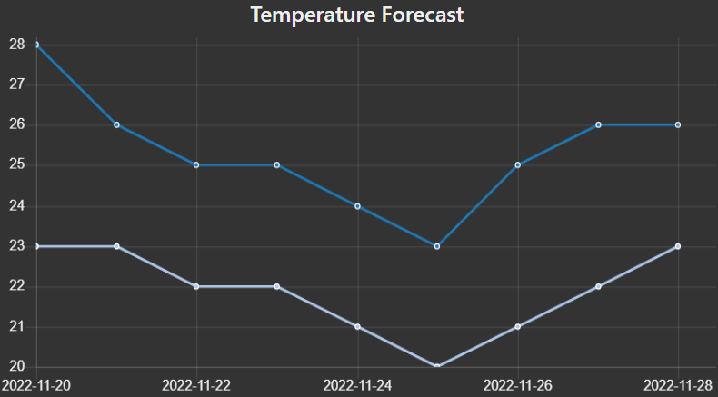

**8. Relative Humidity Forecast**

The chart predicts the humidity in Hong Kong for the next nine days. Humidity will rise over the next few days.

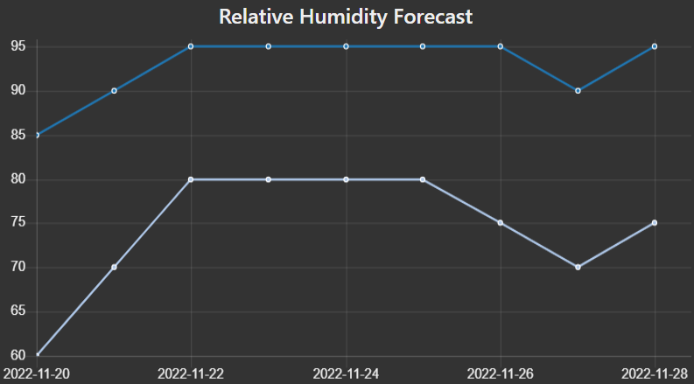

**Correlation**

1. Humidity rises when there are strong fluctuations in temperature. For example: Humidity is at its peak around the time of sun rise and set.
2. When temperatures peak, UV levels also peak.
3. Rainfall is the most direct factor affecting humidity.
4. When the temperature drops, it may be accompanied by rain, and the humidity will also rise.
5. In air quality monitoring, the peak time of PM2.5 is the morning rush hour of commuting. Compared with natural climate factors, it seems that human factors have a greater impact on air quality.

**Implementation Details**

**1. General Method to Update Time and New Record**

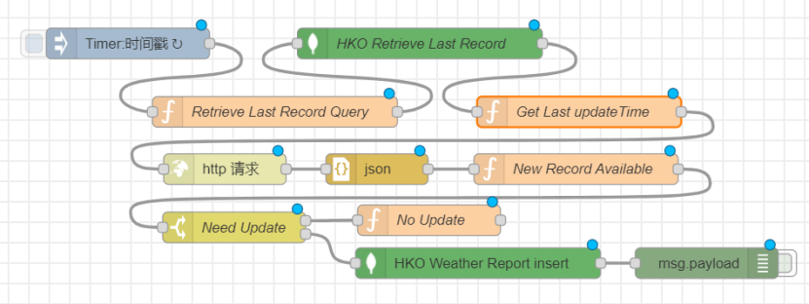

**Implementation for each Nodes:**

Timer: Every five minutes.

Retrieve Last Record Query:

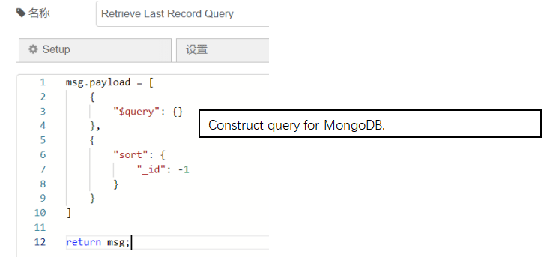

Retrieve Last Record: Send query.

Get Last Update Time:

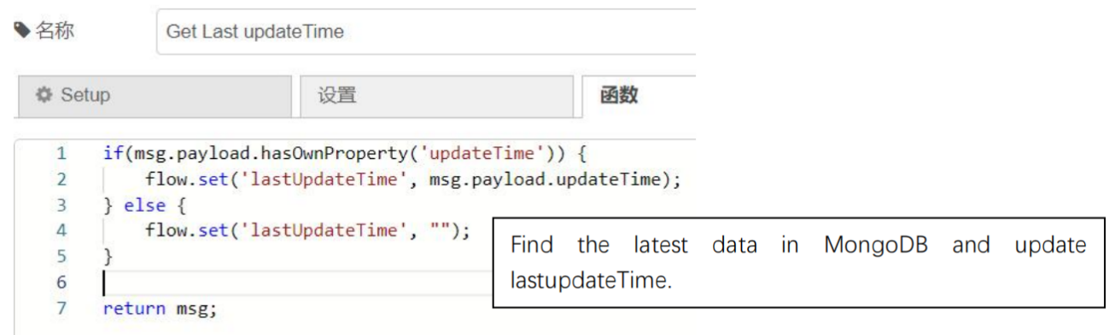

Http Request:

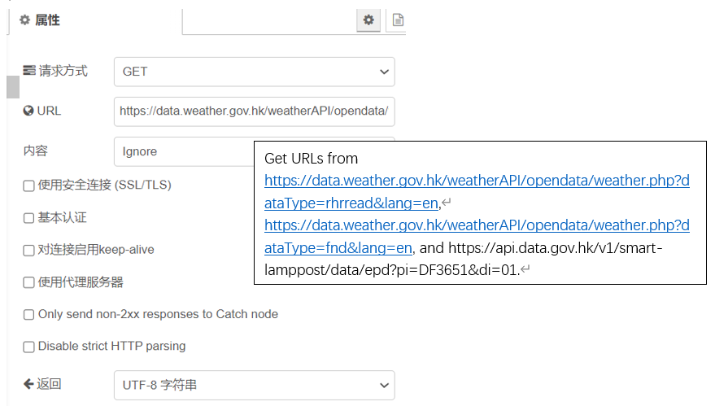

Json: Convert result to JSON.

New Record Available:

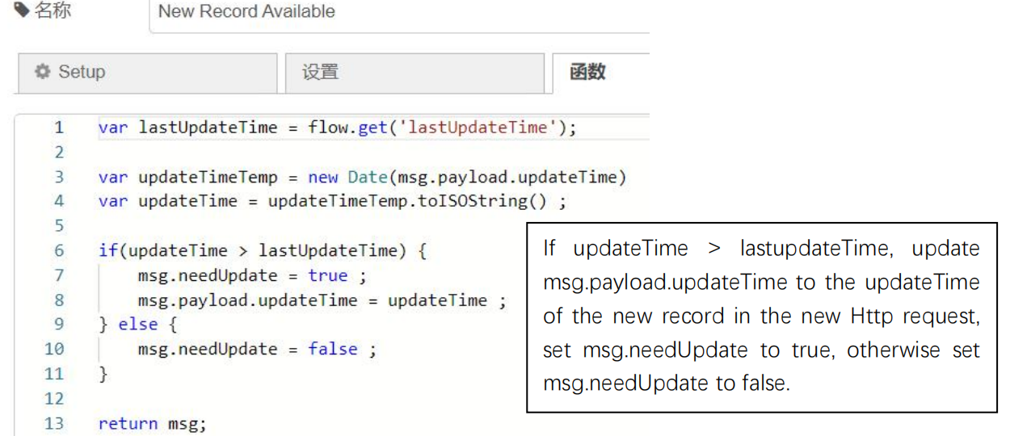

No update: If msg.needUpdate is false, set msg.payload to “No Update”.

Weather Report insert: If msg.needUpdate is true, insert the new record to MongoDB.

**2. General Methods to Construct Queries and Create Format Chart Data**

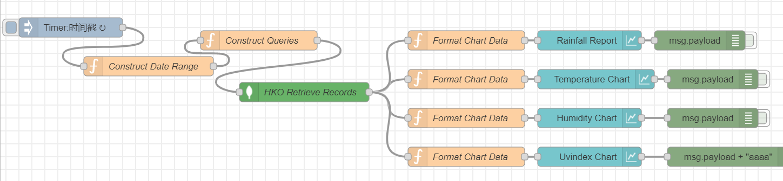

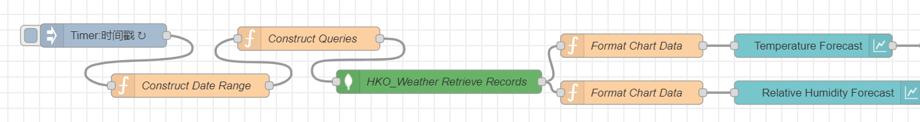

**Implementation for each Nodes:**

Construct Date Range:

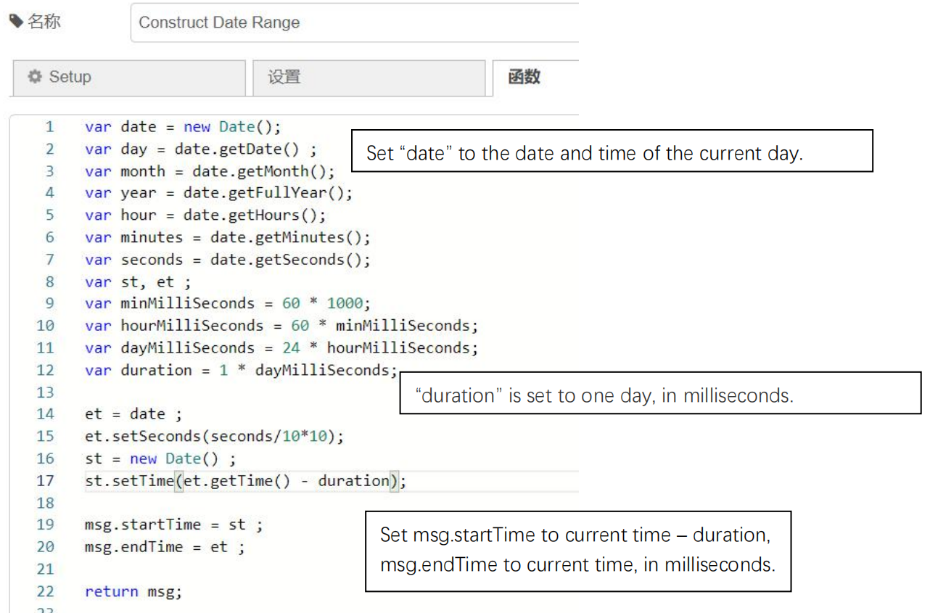

Construct Queries:

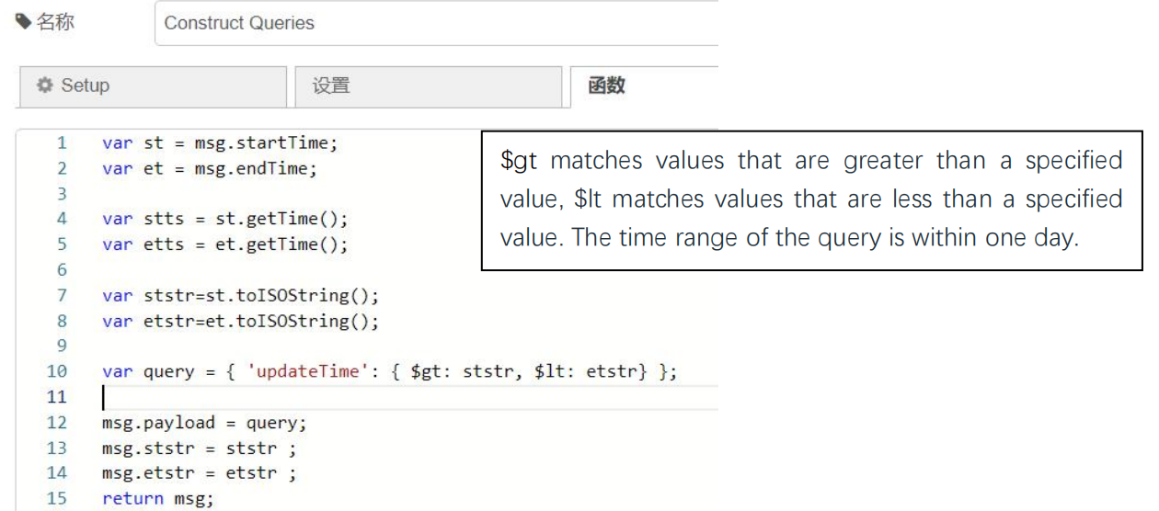

Retrieve Records:

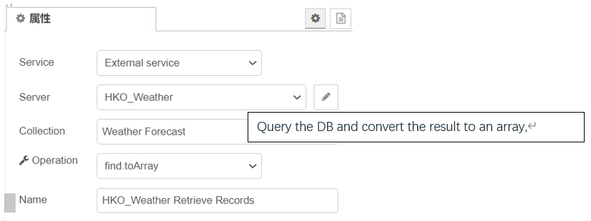

Format Chart Data (Rainfall Report):

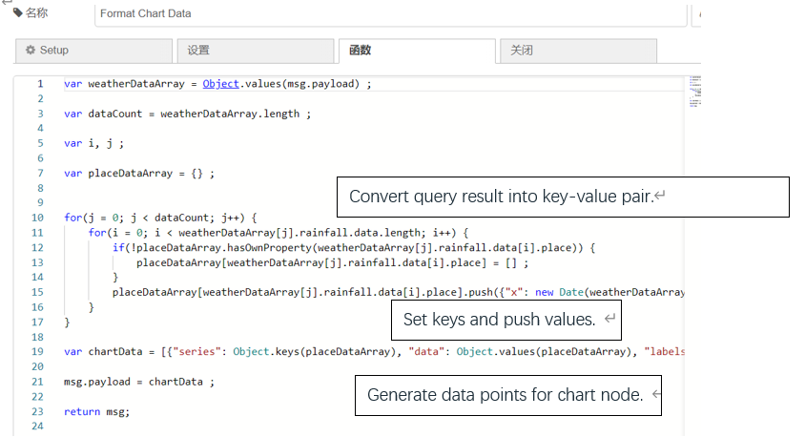

Other "Format Chart Data" nodes (Temperature Forecast, Relative Humidity Forecast, Temperature Chart, Humidity Chart, Uvindex Chart) are similar to Format Chart Data nodes (Rainfall Report).

**3. Implementation for PM2.5 Chart**

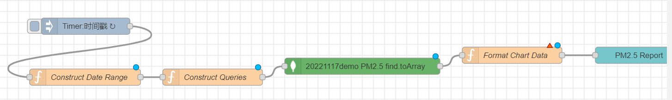

Construct Queries:

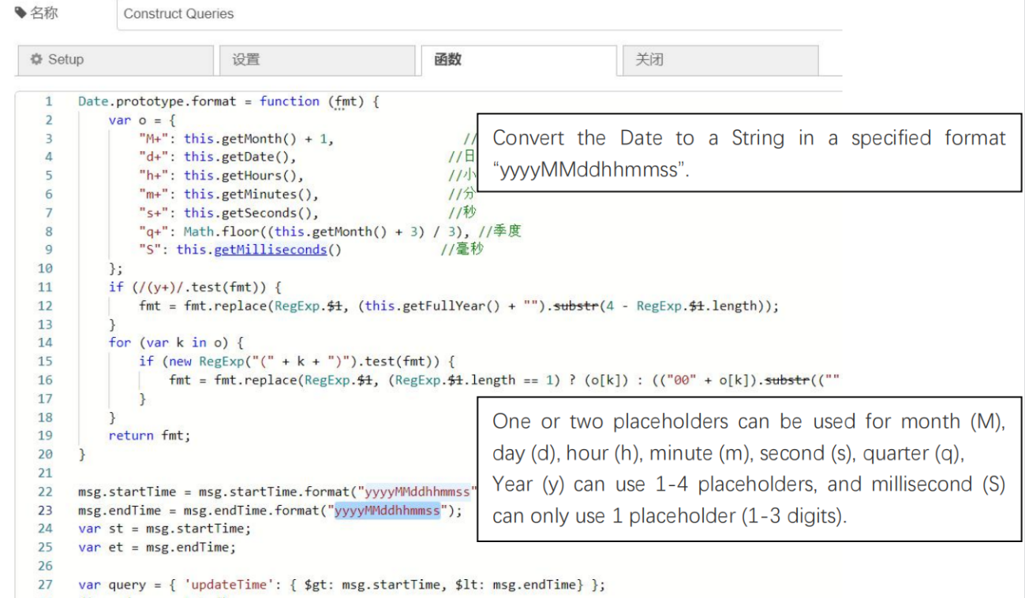

Format Chart Data (PM 2.5):

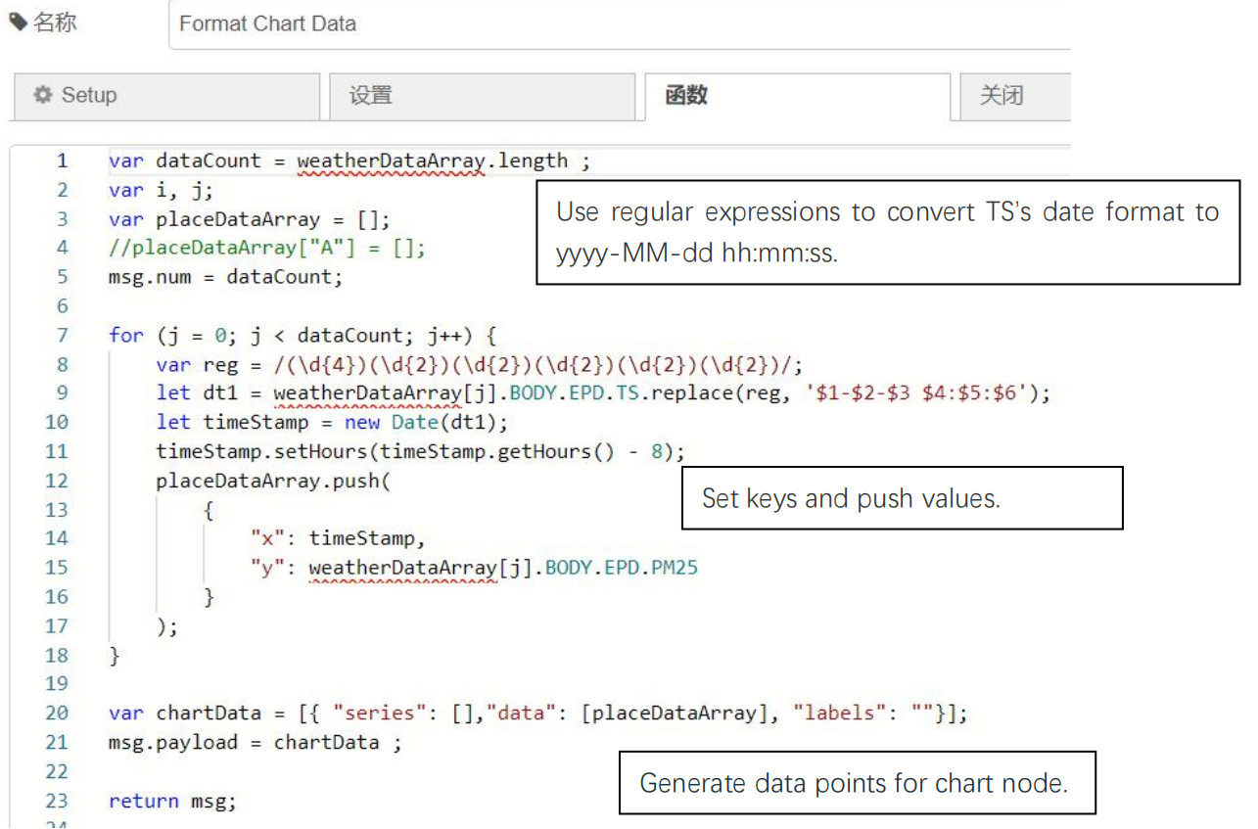

**4. Implementation of Current Information**

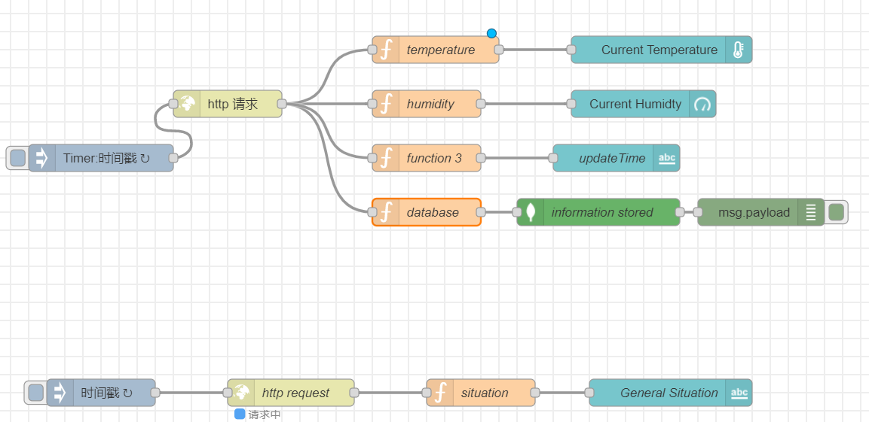

Get the general situation, current temperature, current humidity and updateTime, and generate data to insert it into MongoDB.

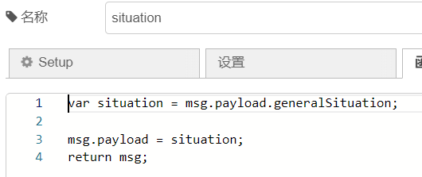

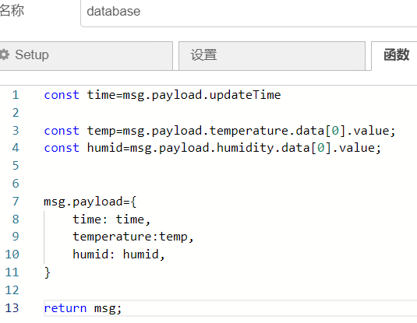

**Data Storing Approach**

MongoDB is a NoSQL Server in which data is stored in BSON (Binary JSON) documents and each document is essentially built on a key-value pair structure. As MongoDB easily stores schemaless data, making it appropriate for capturing data whose structure is not known. So we choose MongoDB as the data storing approach.